Question 19:
Build a dictionary of five actors and the number of movies they have acted in. Add one more actor.
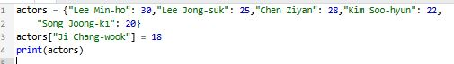
Output:

